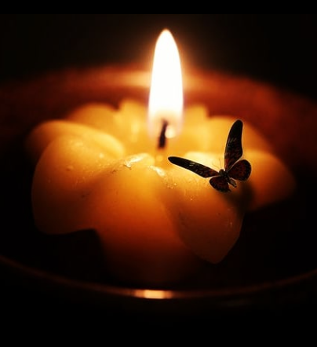
Don't get too attached,
I'm the fire to your moth,
Warm as it may feel,
Bright as it may seem,
But I'm not the water to your draught,

Don't get too attached,
I'm the fire to your moth,
Undeserving of your love,
The flame won't get stubbed,
They'd say I didn't value your worth,

Don't get too attached,
I'm the fire to your moth,
I flicker, I'm fickle,
They're right to say,
All that glitters isn't
Gold,

Don't get too attached,
You're the fire to my moth,
Afriad I'd be engulfed,
But you're the light to my world,

Unsure, unsteady,
Beautiful as it is,
Only ashes will emerge.

